***COMSATS University Islamabad Attock Campus – Pakistan***

*Bachelor of Science in Computer Science 2017-2021*

**LAND PRICE**

**PREDICTOR**

**(An Android Application)**



FYP BY

**Ibtisam Zubair**

**(CIIT/FA17-BCS-065/ATK)**

**Muhammad Abdullah Waheed**

**(CIIT/FA17-BCS-028/ATK)**

*SUPERVISOR*

**Sir Armughan Ali**



**COMSATS University Islamabad**

**Attock Campus, Pakistan**

***Land Price Prediction***

**A project presented to**

**COMSATS University Islamabad, Attock Campus**

**In partial fulfillment**

**Of the requirement for the degree of**

***Bachelor of Science in Computer Science (2017-2021)***

**By**

**Ibtisam Zubair**

**CIIT/FA17-BCS-065/ATK**

**M Abdullah Waheed** **CIIT/FA17-BCS-028/ATK**

**COMSATS University Islamabad**

**Attock Campus- Pakistan**



Submission Form for Final-Year project

PROJECT REPORT

|  |  |  |  |  |  |  |  |  |  |  |  |
| --- | --- | --- | --- | --- | --- | --- | --- | --- | --- | --- | --- |
|  | **PROJECT ID** |  | | | | |  |  | **NUMBER OF** | | 2 |
|  |  |  | **MEMBERS** | |
|  |  |  |  |  |  |  |  |  |  |
|  |  | |  |  |  |  | |  | | |  |
|  | **PROJECT TITLE** | |  |  |  | LAND PRICE PREDICTION | | | | |  |
|  |  | |  |  |  |  | |  |  |  |  |
|  |  | | |  |  |  | |  |  |  |  |
|  | **SUPERVISOR NAME** | | |  | SIR ARMUGHAN ALI | | |  |  |  |  |
|  |  | | |  |  |  | |  | | |  |
|  |  | | | |  |  | |  | | |  |
|  | **MEMBER NAME** | | | |  | **REGISTRATION NO** | | **EMAIL ADDRESS** | | |  |
|  |  | | | |  |  | |  | | |  |
|  | IBTISAM ZUBAIR | | | |  | CIIT/FA17-BCS-065/ATK | | ibtisam.zubair1999@gmail.com | | |  |
|  |  | | | |  |  | |  | | |  |
|  | M ABDULLAH WAHEED | | | |  | CIIT/FA17-BCS-028/ATK | | [incredible.abdullah099@gmail.com](mailto:incredible.abdullah099@gmail.com) | | |  |
|  |  | | | |  |  | |  | | |  |
|  |
|  |

**CHECKLIST:**

Number of pages in this report

I/We have enclosed the soft-copy of this document along-with the codes and scripts created by myself/ourselves

My/Our supervisor has attested the attached document

**I/We confirm to state that this project is free from any type of plagiarism and misuse of copyrighted material**

**YES / NO**

**YES / NO**

**YES / NO**

**MEMBER’S SIGNATURE:**

**__________________________**

_______________________________

**SUPERVISOR SIGNATURE**

_______________________________

DECLARATION

We hereby declare that this software, neither whole nor as a part has been copied out from any source. It is further declared that we have developed this software and accompanied report entirely on the basis of our personal efforts. If any part of this project is proved to be copied out from any source or found to be reproduction of some other. We will stand by the consequences. No Portion of the work presented has been submitted of any application for any other degree or qualification of this or any other university or institute of learning.

IBTISAM ZUBAIR _________________________

M ABDULLAH WAHEED ______________________

**CERTIFICATE OF APPROVAL**

It is to certify that the final year project of BS(CS) “LAND PRICE PREDICITION” was developed by IBTISAM ZUBAIR (CIIT/FA17-BCS-065/ATK) and M ABDULLAH WAHEED (CIIT/FA17-BCS-028/ATK), under the supervision of SIR ARMUGHAN ALI and in his opinion; it is fully adequate, in scope and quality for the degree of Bachelors of Science in Computer Sciences.



**Supervisor**

Sir Armughan Ali

Lecturer

Computer Science Department

COMSATS University Islamabad, Attock Campus



Dr. Khalid Mehmood Awan

HOD

Computer Science Department

COMSATS University Islamabad, Attock Campus

**ACKNOWLEDGEMENT**

All praise is to Almighty Allah who bestowed upon us a minute portion of His boundless knowledge by virtue of which we were able to accomplish this challenging task.

We are greatly indebted to our project supervisor SIR ARMUGHAN ALI. Without his personal supervision, advice and valuable guidance, completion of this project would have been doubtful. We are deeply indebted to them for him encouragement and continual help during this work.

We are grateful and thankful to our parents, who're always being supportive to us, helped and kept us motivated throughout the journey from then to now with this project. Not only that but they also gave us moral support and financial help. In true meanings, we would have not made till now without them. We are truly thankful to our whole family for being supportive and helping us in every aspect to be mentioned.

IBTISAM ZUABIR

_________________

MUHAMMAD ABDULLAH WAHEED

_________________

**EXECUTIVE SUMMARY**

For many people, buying a property is one of the most important decision and purchase in life. Besides the affordability of a house other factors such as the desirability of the location and the long-term investment prospects also affect the decision-making process. Now-a-days people face a lot of problems when they wanted to buy a new land or plot. The major issue is about its price in future. It is very difficult to predict the price of land in future. According to previous knowledge of price and area’s facilities experts can predict its price in future. But in this app we can predict the land price for about 10 years further based on facilities, crime rate and location. It can help people to find a perfect land or plot for commercial use as well as domestic. It will also help property dealers and real estate companies, so that they can invest their money on right place.

We are going to make an Android based Land Price Prediction System to predict future land prices in a specific area based on available resources and previous prices of that area using machine learning algorithms. In our system user can easily find the best land for him/her so that his problems get solved. We know that prices of lands are increasing day by day. It is a difficult task to choose the best land for a user in coming years and predict the price of that land in future. Our Application provides an easy menu for user where he/she will choose their particular areas, dimensions and orientations and our system will suggest the suitable land and predict future price based on available resources and previous prices of that area.

There will also an Admin Menu where records are updated time to time. If resources increases or availability of land increases or decreases in that particular area then it will also be updated in records.

Table of Contents

1 Introduction 12

1.1 Brief 12

1.2 Relevance to Course Modules 13

1.2.1 Mobile Application Development 13

1.2.3 Report Writing Skills 13

1.3 Project Background 14

1.4 Literature Review 14

1.4.1 Check land Prices 14

1.4.2 London House Pricing Application 15

1.4.3 Zillow 16

1.5 Analysis from Literature Review 18

1.6 Methodology and software lifecycle for this project 18

2 Problem Definition 21

2.1 Problem Statement 21

2.2 Deliverables and Development Requirements 22

3 Requirement Analysis 25

3.1 Use case diagrams 25

3.2 Detailed Use case 28

3.3 Functional requirements 30

3.4 Non Functional requirements 32

Reliability 33

Speed 33

Security 33

Performance 33

Portability 33

Complexity 33

Testability 33

Integrality 33

Robustness 33

Modifiability 33

Usability 33

Efficiency 33

Scalability 33

Availability 33

Maintainability 33

4 Design and architecture 35

4.1 System Architecture 35

4.2 Process flow/representation 36

4.3 Data flow Diagram level 0: 39

4.4 Sequence Diagram 40

41

4.5 Entity-Relationship Diagram 42

Chapter 1

**Introduction**

# Introduction

## Brief

With the progression of time, the world is confronting numerous issues. Those issues are being understood, yet additionally they are being modernized and enhanced each day. For instance, open managing for buying and selling stuff. We used to go to the market and now, we have applications like OLX where we can sell and buy stuff just by sitting at home. This tackled our concern as well as revolutionized the business for better. Presently one of the issue the vast majority face is the point at which they are going to buy some property or land. We have the traditional method for reaching a property seller or visiting the land ourselves and accumulate data about the region ourselves. Presently remember that a portion of the time this data can be phony and can thoroughly blowback on certain individuals and in certain situations the cost may likewise contrast and can without much of a stretch be controlled. After some exploration, we thought of an arrangement to conquer this issue and take care of business. In the light of the previously mentioned issues, we concocted the undertaking called “LAND PRICE PREDICTION SYSTEM”. Imagine a scenario in which we disclose to you that all the data you require is only a tick away. Imagine a scenario where I disclose to you that everything, from cost to territory, Area portrayal (which includes crime percentage, fundamental living prerequisites) and by what method will the land develop to be in the up and coming years, is exactly readily available. Okay trust it? Well it appears to be unbelievable yet it isn't outlandish! With a little exertion, we will have the option to accomplish this, what we can say is dream. For this reason we need to chip away at an application that will give us the interface that will assist us with interacting with the client. The client will enter the subtleties of the plot for example Value, area, forth and the application will anticipate the estimation of the land or plot and how much of benefit will the land give in the forthcoming years. From the start this application will be pertinent in a portion of the piece of the city, later it will be a huge worldwide marvel.

## Relevance to Course Modules

1.2.1 Mobile Application Development  
In our project we are using Android Studio. Android Studio is the IDE that provides Google to develop professional Android applications. It is used to develop a different variety of applications for the Android operating system. It is an  
IDE &amp; platform to design a user-friendly interface by drag and drop.  
  
1.2.2 Machine Learning  
In this course we have studied about different algorithms which are used to train models to  
perform task automatically after getting the training data.

1.2.3 Report Writing Skills  
This course is about learning how to write reports and other formal documentation, and in our  
project, we need to write documentation of our project.  
  
1.2.4 Software Engineering  
In our project, we have different diagrams (erd, class diagram, dfd diagrams, sequence diagram, use case diagram, activity diagram) that we learned in software engineering course.

## Project Background

Now-a-days purchasing of land/plot is a major issue because fraud is very common in our society. Future price prediction of a land for a normal or lay person is very difficult. Unfortunately there is no proper prediction system or application implemented in Pakistan.

Although there are many real estate buying and selling apps available but unfortunately there is no proper prediction system or application implemented here. The traditional systems based on property advisors might contain many drawbacks like fraud, robbery etc.

By keeping these problems in mind, we proposed this system in which all the predictions are performed by system. Administration can easily add, delete or modify data in the app and a lay person can easily get benefited.

## Literature Review

We started the project by searching for an android system that are predicting future house and land prices. From research we came to know that there is no such system present in Pakistan that works on prediction. But globally there are some other systems which perform prediction related to houses but not for lands. Also there is no proper android application available for that purpose. Following are those systems;

### 1.4.1 Check land Prices

This Android app has area wise land pricing details it works only in India. It deals with land valuation and property valuation. If you want to buy land in another place or city, you can easily find land prices of other cities through this app.

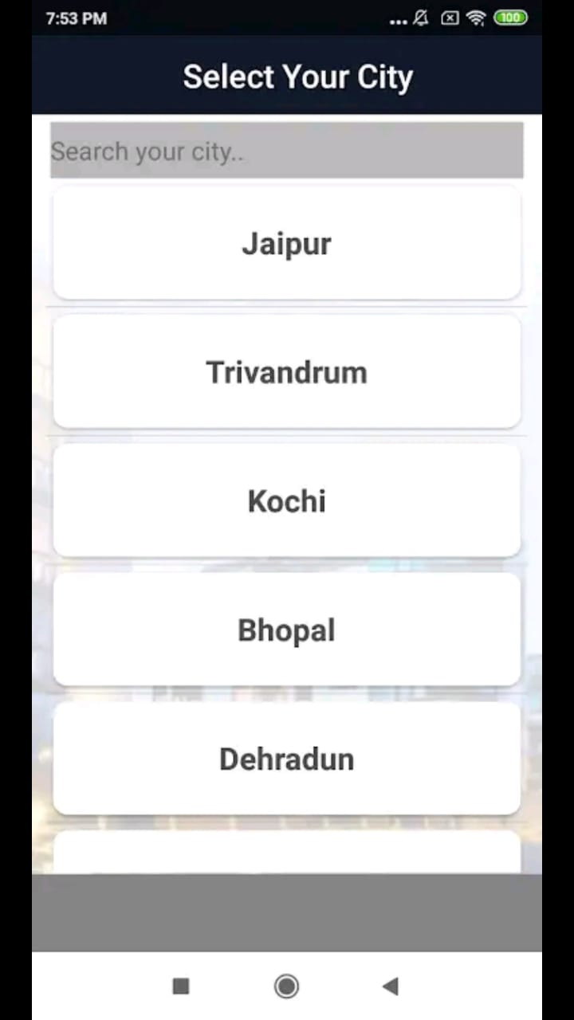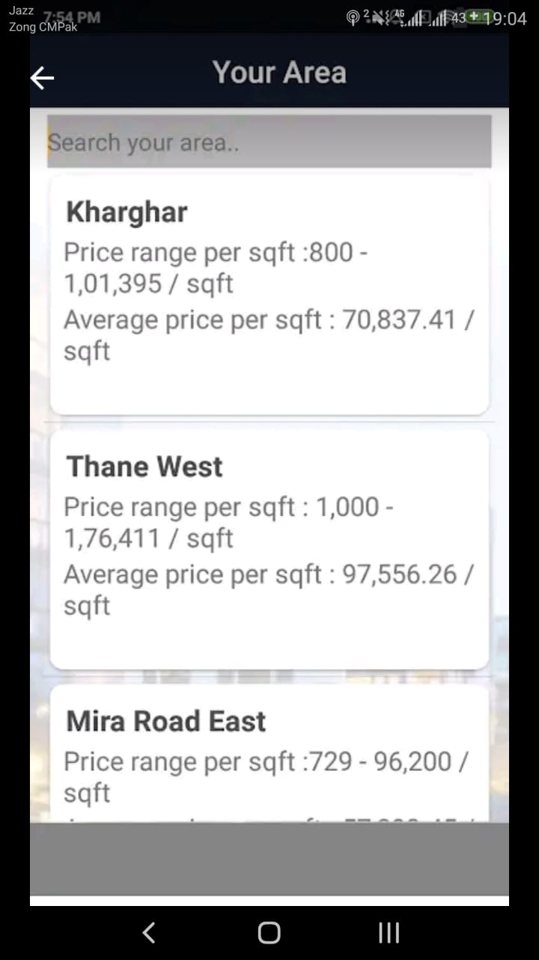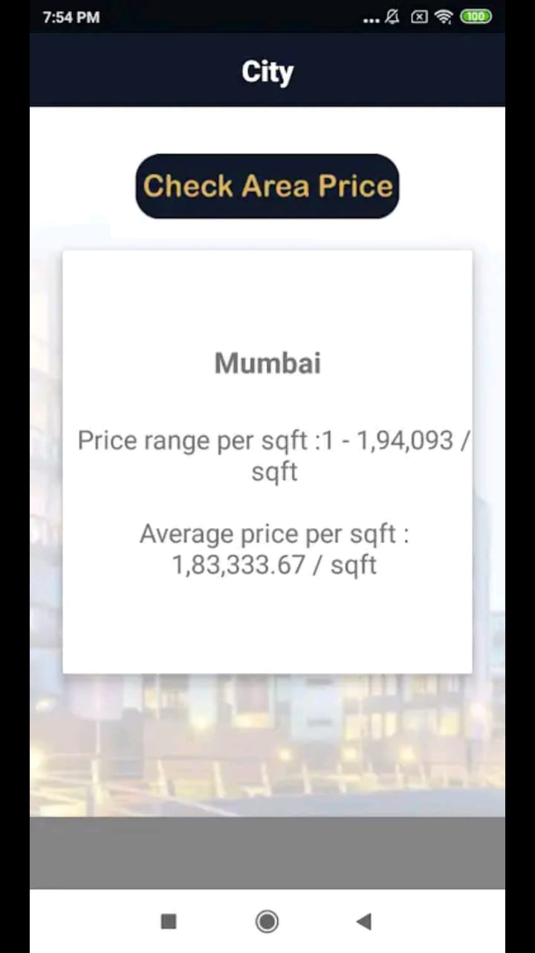

### 1.4.2 London House Pricing Application

The goal of the project is to create a mobile application that can provide users with location-specific predictions and trends on London housing market. Users of the application should be able to obtain the following information:

1. Future price changes of London properties that fall within a user-defined search radius, which can be fine-tuned by options such as property type

2. Locations that can be considered within a search radius, given a purchasing budget from the user

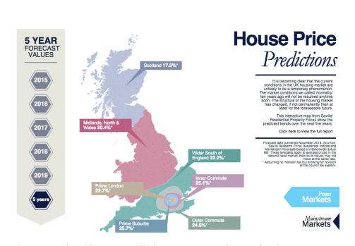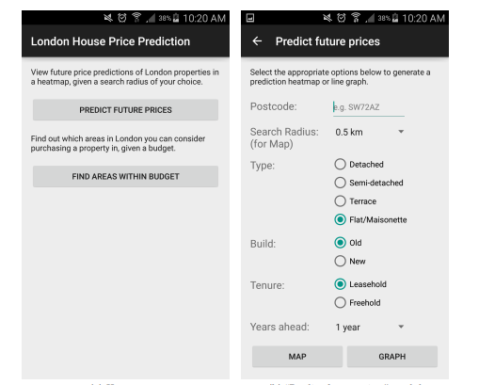

### 1.4.3 Zillow

Zillow launched in 2006 and is headquartered in Seattle (U.S.A).

Zillow is the leading real estate and rental marketplace dedicated to empowering consumers with data, inspiration and knowledge around the place they call home, and connecting them with the best local professionals who can help.

Zillow serves the full lifecycle of owning and living in a home: buying, selling, renting, financing, remodeling and more. It starts with Zillow’s living database of more than 110 million U.S. homes – including homes for sale, homes for rent and homes not currently on the market, as well as Z-estimate home values, Rent Z-estimates and other home-related information. Zillow operates the most popular suite of mobile real estate apps, with more than two dozen apps across all major platforms.

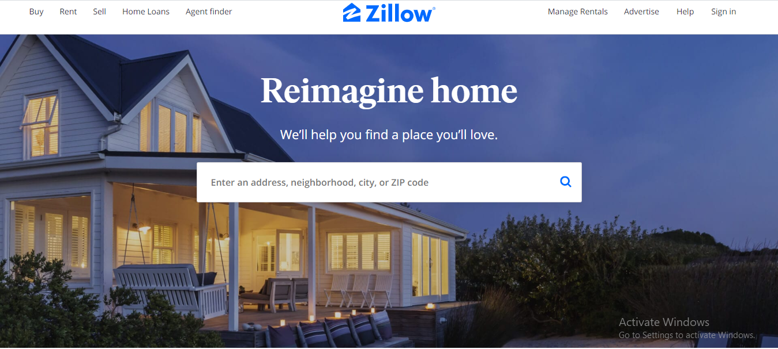

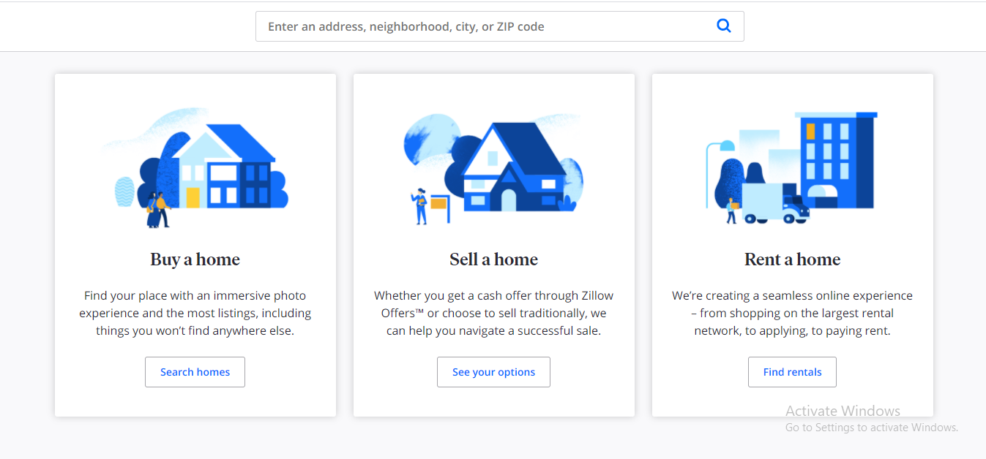

## Analysis from Literature Review

|  |  |  |  |  |
| --- | --- | --- | --- | --- |
| Company | Type | Future Price Prediction | House/Land | Standard/Local Currency rate |
| Machine Learning for London Housing Price Prediction Mobile Application | Android | Yes | House | Local |
| Check Land Prices | Android | No | Land | Local |
| Zillow | Android/Web | No | House | Standard |
| Land Price Predictor | Android | Yes | Land | Standard |

## Methodology and software lifecycle for this project

Methodology used is “agile development methodology”. The software life cycle of agile model is followed here.

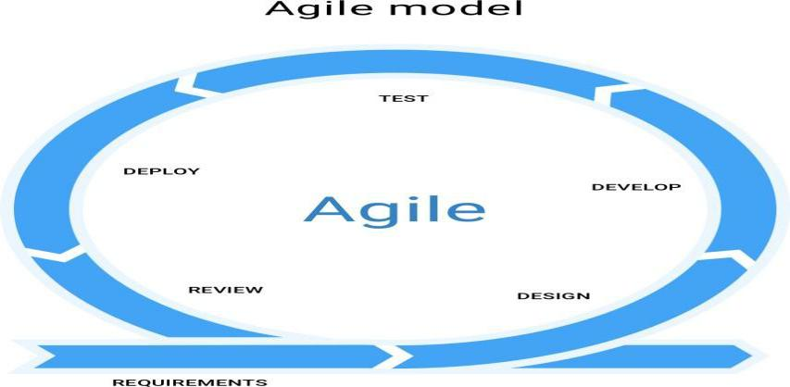

Step of life cycle:

* Requirements

In this step we collect the requirements for our project through questioners and expert views of different land dealers and advisors. From their knowledge we generate our Data Set.

* Design

In this step, we first make the uml diagrams for the system and then make interfaces for the system.

* Develop

In this step, we develop the system modules one by one.

* Test

             In this step, we conduct the test of developed module in order to check its

functionality.

* Deploy

In this step, we first integrate the modules and then deploy the system in that environment in which it is used.

* Review

After deployment, users of the system use it and give review about system. From these review, we learn about the performance of our system.

**Rationale behind Selected Methodology**

We use “agile development methodology” for developing our project because the system is developed in a series of versions or increments with the involvement of stakeholders in specification of version and system evaluation.

Chapter 2

**Problem Definition**

# Problem Definition

For many people, buying a property is one of the most important decision and purchase in life. Besides the affordability of a house other factors such as the desirability of the location and the long-term investment prospects also affect the decision-making process. Now-a-days people face a lot of problems when they wanted to buy a new land or plot. The major issue is about its price in future. It is very difficult to predict the price of land in future. According to previous knowledge of price and area’s facilities experts can predict its price in future.

To overcome the above problems we introduce and automated system in the form an Android Application named “Land Price Predictor”. We are using records of lands of different areas and provide most precise prediction using Machine Learning Algorithms in efficient way in order to help users. This application will also be useable for land experts and dealers. In this app we can predict the land price for about 10 years further based on facilities, crime rate and location. It can help people to find a perfect land or plot for commercial use as well as domestic. It will also help property dealers and real estate companies, so that they can invest their money on right place.

## Problem Statement

Now-a-days purchasing of land/plot is a major issue because fraud is very common in our society. Future price prediction of a land for a normal or lay person is very difficult. Unfortunately there is no proper prediction system or application implemented in Pakistan.

Although there are many real estate buying and selling apps available but unfortunately there is no proper prediction system or application implemented here. The traditional systems based on property advisors might contain many drawbacks like fraud, robbery etc. Major problems with traditional system are;

* Difficult to search specific land according to needs.
* Time and effort consuming.
* Risk of fraud.

## Deliverables and Development Requirements

***Deliverables:***

* The Land Price Predictor is an Android based prediction system, there are two sub systems, one is Admin Menu and the other is user menu or view.
* In Admin Menu, there is login system for Admin, Admin can add new records, delete the old or non-useful records and modify the existing records time to time when needed. All the data is stored in the database of Android Application i.e. Firebase.
* The other side is User’s Menu, User can sign in using Gmail or Face book. After login, user can set his/her requirements such as select location, area, plot size etc, and in response the system predicts the most précised price for that particular land in the future.

***Development Requirements:***

Development requirements include tools and technologies that we are using in our system.

Table 2.2.1 Tools used in project

|  |  |
| --- | --- |
| **Tools** | **Rationale** |
| Pycharm | For implementation of Machine Learning algorithms using python |
|  |  |
| Star Uml (version 2.8.1) | Project diagrams |
|  |  |
| DIA | Project diagrams |
|  |  |
| MS Word (2010) | Documentation |
|  |  |
| MS PowerPoint (2010) | Presentation |
|  |  |
| Android Studio (version 3.5.3) | For making android application |
|  |  |

Table 2.2.2 Technologies used in project

|  |  |
| --- | --- |
| **Technology** | **Rationale** |
| SQL(version 2013) | Query Language |
| Basic concepts of python | For machine learning |
| Firebase database | Database for android application |
|  |  |
| Java Programming Language | Building block for android programming/ Designing and |
|  | development of application |
|  |  |

,

Chapter 3

**Requirement Analysis**

# Requirement Analysis

## Use case diagrams

The system’s use case shows the user a full view of the scheme and how actors would interact with the system. It is a graphical depiction of the interactions among the elements of the system.

In our system, there are total 2 actors, an admin and a user. We make separate use case diagrams for each actor in order to ensure the clarity of diagram.

Table 5.1.1 Use case diagram elements [7]

|  |  |  |  |  |
| --- | --- | --- | --- | --- |
| **No** | **Elements name** |  | **Symbols** | |
| 1 | Actor |  |  |  |
|  |  |  |  |  |
| 2 | Use case |  |  |  |
|  |  |  |  |  |
| 3 | Association |  |  |  |
|  |  |  |
|  |  |  |  |  |

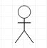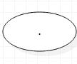

**Figure 3.1.1 Use case diagram: Admin**

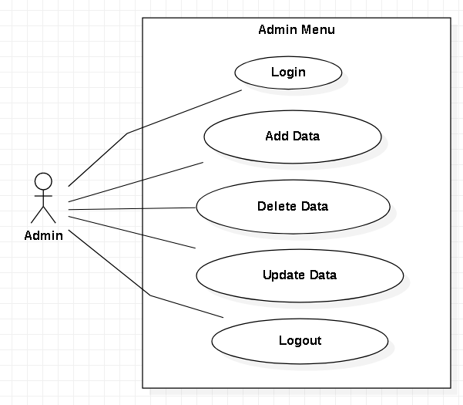

**Figure 3.1.2 Use case diagram: Admin (android application user)**

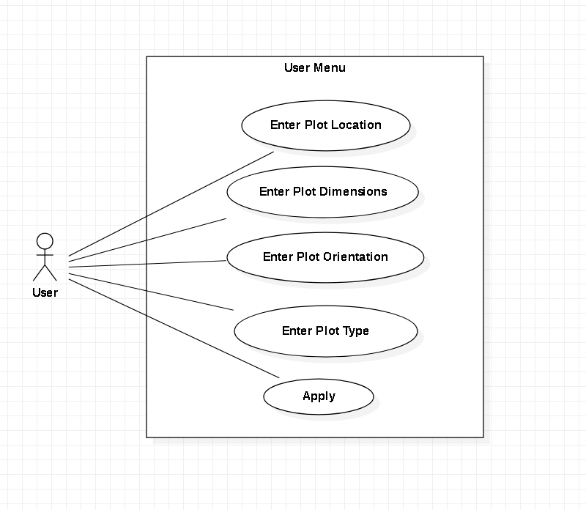

**Figure 3.1.2 Use case diagram: User (android application user)**

## Detailed Use case

Table 3.2.1 Use case: admin menu

|  |  |  |
| --- | --- | --- |
| Use Case ID: |  | UC-1 |
| Use Case |  | admin login |
| Name: |  |  |
|  |  |  |
| Actors: |  | admin |
|  |  |  |
| Description: |  | Admin login into the system and perform his |
|  |  | Duties. |
|  |  |  |
| Trigger: |  | Admin indicates that he /she want to login. |
|  |  |  |
| Preconditions: |  | Admin should be given a Username and password |
|  |  | for login |
|  |  |  |
| Post |  | After accessing it, portal shown to admin. |
| conditions: |  |  |
|  |  |  |
| Normal Flow: |  | a) Click to login portal. |
|  |  | b) First enter password and Username |
|  |  |  |
| Alternative Flows: |  | Cancel action. |
|  |  |  |
| Exceptions: |  | If password wrong or any other mistake in login, it does |
|  |  | not allow the admin to access the system. Pop-up |
|  |  | Message is shown on screen. |
|  |  |  |

Table 3.2.1 Use case: User Menu

|  |  |  |
| --- | --- | --- |
| Use Case ID: |  | UC-1 |
| Use Case |  | User menu |
| Name: |  |  |
|  |  |  |
| Actors: |  | User |
|  |  |  |
| Description: |  | User login into the system and check the desired results |
|  |  |  |
|  |  |  |
| Trigger: |  | User indicates that he /she want to login and check the desired output. |
|  |  |  |
| Preconditions: |  | User must have login through Gmail or face book to get |
|  |  | started |
|  |  |  |
| Post |  | After accessing it, portal is shown to User |
| conditions: |  |  |
|  |  |  |
| Normal Flow: |  | a) Click to login portal. |
|  |  | b) Enter Gmail or Face Book ID for login |
|  |  |  |
| Alternative Flows: |  | Cancel action. |
|  |  |  |
| Exceptions: |  | If Gmail or Face Book account of user doesn’t exist, it does |
|  |  | not allow the user to access the system. Pop-up |
|  |  | Message is shown on screen. |
|  |  |  |
|  |  |  |

## Functional requirements

These are constrains that must be followed during the coding and without satisfying these constrains solution is not valid. Functional requirements describe the expected behavior of the system. These are the core system requirement and without implementing any of these requirements the system is supposed to be incomplete.

We document few functional requirements of our system, following are those:

Table 3.3.1 FR: login

|  |  |
| --- | --- |
| Identifier | FR 1 |
|  |  |
| Title | Login/authentication |
|  |  |
| Requirement | The login page will take data from and will check |
|  |
|  | the validity of input fields to keep users and admin record saved efficiently and effectively. |
|  |  |
|  |  |
| Dependencies | FR2, FR3,FR4,F5,F6, F7  User registration, User must have Google or Face Book account to login  Users must be connected to the Internet since the App only works in online mode. |
|  |  |
| Priority | High |
|  |  |
|  |  |
|  |  |

Table 3.3.2 FR: logout

|  |  |
| --- | --- |
| Identifier | FR 2 |
|  |  |
| Title | Logout |
|  |  |
| Requirement | System provides logout functionality to users. Users should be able to successfully logout at any given time from the system. |
|  |
|  |  |
| Dependencies | Users must be logged into the system. |
| Fit Criterion | After logout, the user will exit from the system and will be redirected to the login screen. |
|  |  |

Table 3.3.3 FR: View records

|  |  |
| --- | --- |
| Identifier | FR 3 |
|  |  |
| Title | Admin/ view the records of lands |
|  |  |
| Requirement | Admin will have option to view the records of lands |
|  |
|  | . |
|  |  |
|  |  |
| Priority | High |
|  |  |

Table 3.3.4 FR: Add records

|  |  |
| --- | --- |
| Identifier | FR 4 |
|  |  |
| Title | Admin/ Add new records |
|  |  |
| Requirement | Admin will have option to add new records |
|  |
|  | . |
|  |  |
|  |  |
| Priority | High |
|  |  |

Table 3.3.5 FR: Delete records

|  |  |
| --- | --- |
| Identifier | FR 5 |
|  |  |
| Title | Admin/ Delete records |
|  |  |
| Requirement | Admin will have option to delete the records of lands |
|  |
|  | . |
|  |  |
|  |  |
| Priority | High |
|  |  |

Table 3.3.6 FR: Update records

|  |  |
| --- | --- |
| Identifier | FR 6 |
|  |  |
| Title | Admin/ Update records |
|  |  |
| Requirement | Admin will have option to update the records of land and resources time to time. |
|  |
|  | . |
|  |  |
|  |  |
| Priority | High |
|  |  |

Table 3.3.7 FR: User Menu

|  |  |
| --- | --- |
| Identifier | FR 7 |
|  |  |
| Title | User menu/ user login |
|  |  |
| Requirement | User will have various options to select the desired requirements and the system will respond the user by predicting the price of that particular land |
|  |
|  | . |
|  |  |
|  |  |
| Priority | High |
|  |  |

## Non Functional requirements

Nonfunctional requirements are related to the environment in which system is going to be

Operated; it does not directly associate to the functionality of system. Following are functional

Requirements of our system:

|  |  |
| --- | --- |
| **Properties** | **Measures** |
| Reliability | System should function properly at any given time and respond in the expected way.  System should not suffer from frequent down time.  The application will meet all of the functional requirement without any unexpected behavior and System should be Recoverable and Accurate |
| Speed | System should be robust and not lag or crash |
| Security | User data integrity should not be at stake.  Records should not be compromised and manipulated. |
| Performance | Fast Response time  high Throughput (number of operations performed per second) |
| Portability | Application runs on any android OS version |
| Complexity | Application should be simple and all modules should avoid unwanted dependencies. |
| Testability | Ease of learning  Ease of reporting |
| Integrality | All components well integrated and complement each other. |
| Robustness | In the presence of faults, stress and invalid inputs |
| Modifiability | Provision in system for future addition of new functionalities |
| Usability | Effort require to learn, use, provide, input and interrupt result of the program |
| Efficiency | Minimal use of resources (disk, network, memory and processor) |
| Scalability | For large number of user or quantities of data |
| Availability | This application will available all time on the user android device |
| Maintainability | This application can maintained easily |

Table 3.4.1 Non Functional Requirements

Chapter 4

**Design & Architecture**

# Design and architecture

The overall structure of a project or a system is easily understandable graphically. The design and architecture of system is explained with the help of the diagrams. All of these diagrams provide clear picture of all the interactions taking place in the system. These diagrams provide a detailed infrastructure of the project. Every step of the system is explained below with diagrams.

## System Architecture

Our system is a land Price Prediction System that contains two modules and one centralized database. The rectangle shape shows the sub-systems/modules and the circle shows the centralized database. In our system, the two sub-systems works independently (means admin and users) but both sub-systems are linked through one centralize database.

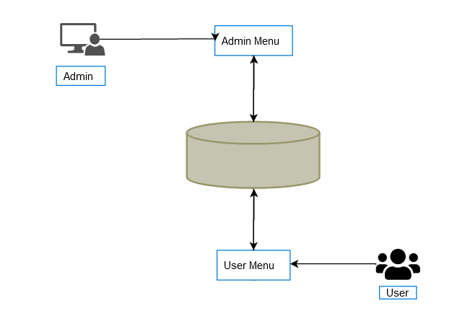

## Process flow/representation

Activity diagram is used for representing the process flow. In this diagram, we check the graphical representation of process flow. Activity diagram is an important diagram in UML which is used to describe the dynamic aspects of the system. Activity diagram is basically a flowchart to represent the flow from one activity to another activity.

Table 4.2.1 Activity diagram elements

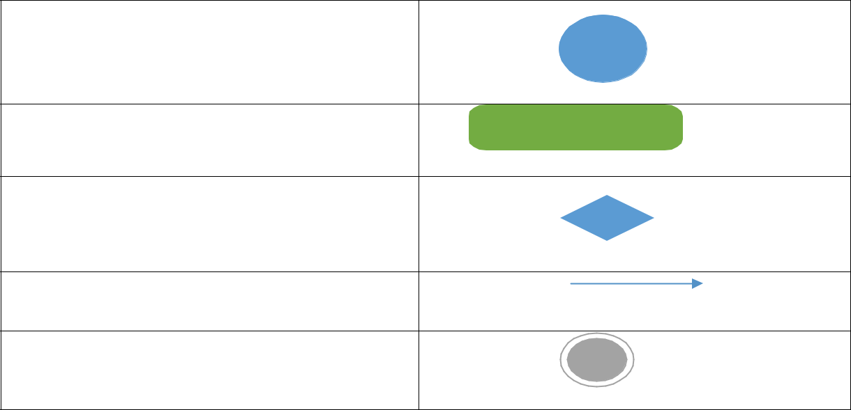

Starting symbol

Action state

Decision

Data flow

Final node

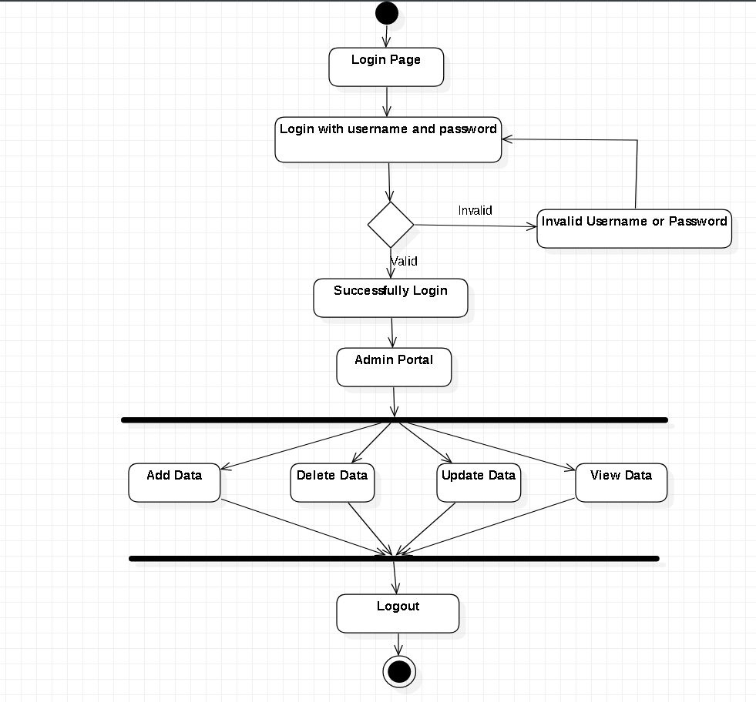

**Figure 4.2.1 Activity diagram: Admin**

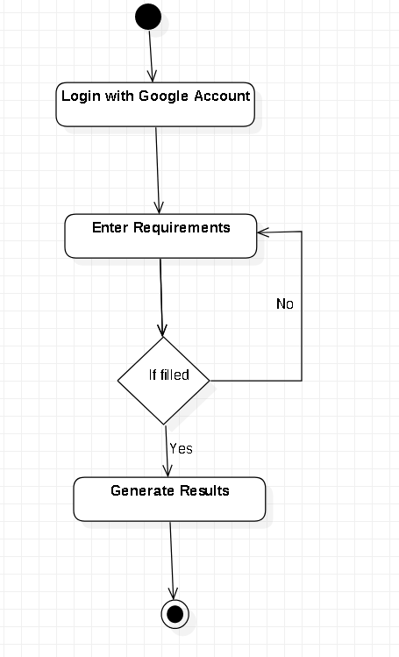

**Figure 4.2.2 Activity diagram: User**

## Data flow Diagram level 0:

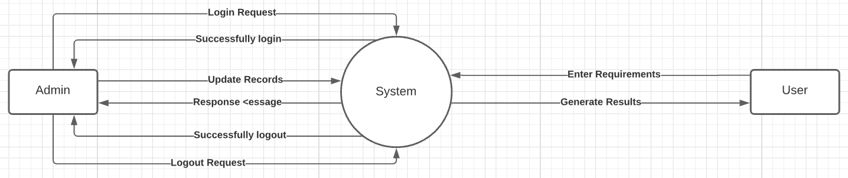

**Figure 4.2.3 DFD0 Diagram**

## Sequence Diagram

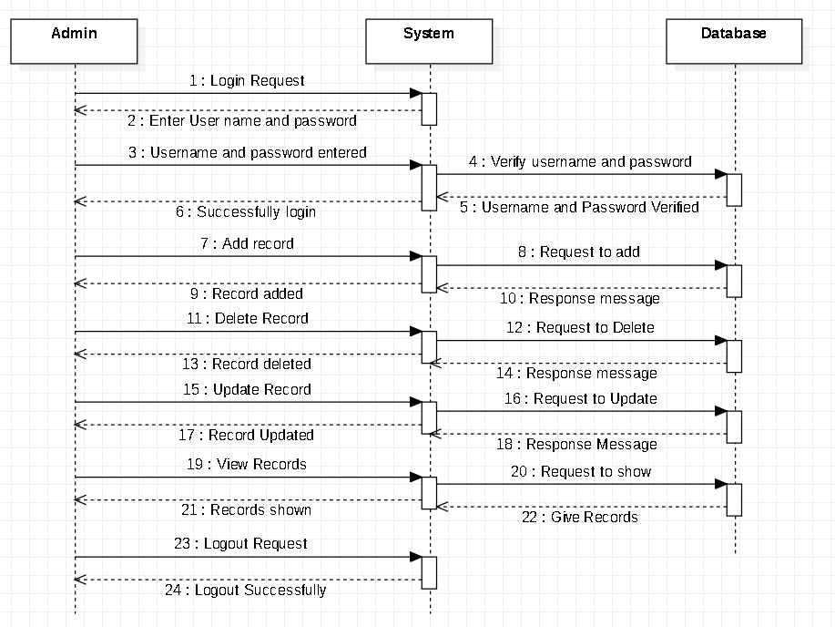

**Figure 4.2.5 Sequence Diagram : Admin**

## systemUser.PNG

**Figure 4.2.6 Sequence Diagram: User**

## Entity-Relationship Diagram

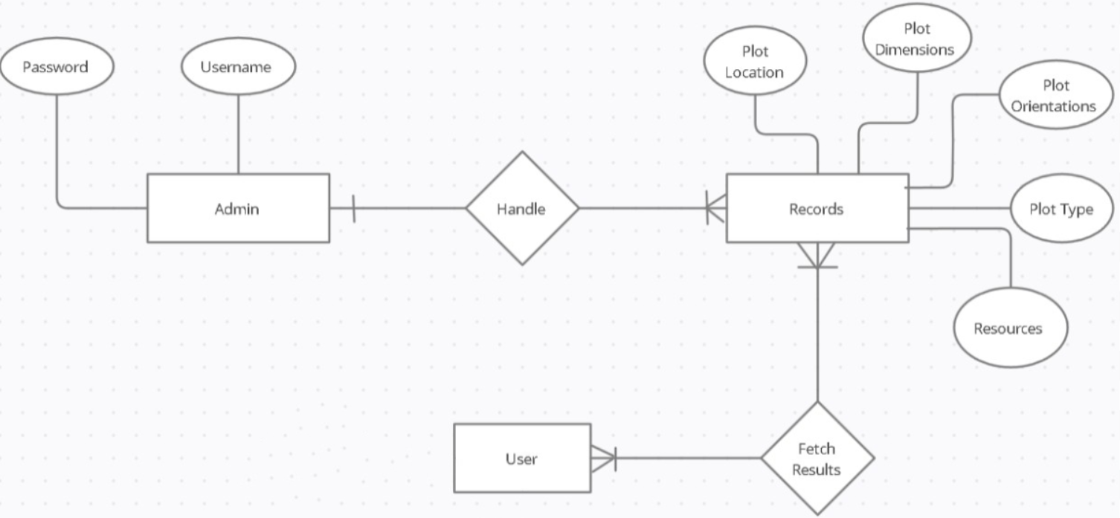

**Figure 4.2.7 Entity Relationship Diagram**